EV (Extended Validation)
# Source: AI Source: Provided by: [Data Path: Persons Table -> ID Column: 1, Name_En Column: Motasem Essam] -> From: [ChatGPT] on [1/18/2026]
EV (Extended Validation) is the highest level of SSL/TLS certificate validation. It provides the strongest identity verification by confirming the legal, physical, and operational existence of an organization behind a website.

🔐 What EV (Extended Validation) Is
# Source: AI Source: Provided by: [Data Path: Persons Table -> ID Column: 1, Name_En Column: Motasem Essam] -> From: [ChatGPT] on [1/18/2026]
- Verifies domain ownership
- Performs strict organization identity checks
- Confirms legal existence, location, and authority
- Intended for high-trust, high-risk websites

🛠️ How EV Validation Works
# Source: AI Source: Provided by: [Data Path: Persons Table -> ID Column: 1, Name_En Column: Motasem Essam] -> From: [ChatGPT] on [1/18/2026]
The Certificate Authority (CA) verifies:
- Domain control
- Legal existence of the organization
- Physical address and business registration
- Operational existence
- Authority of the requester to obtain the certificate
⏱️ Time to issue: Several days

📍 Where EV Certificates Are Used
# Source: AI Source: Provided by: [Data Path: Persons Table -> ID Column: 1, Name_En Column: Motasem Essam] -> From: [ChatGPT] on [1/18/2026]
- Banking and financial institutions
- Payment gateways
- E-commerce platforms
- Government websites
- Enterprise and regulated industries

✅ Advantages
# Source: AI Source: Provided by: [Data Path: Persons Table -> ID Column: 1, Name_En Column: Motasem Essam] -> From: [ChatGPT] on [1/18/2026]
- Highest level of identity assurance
- Strong protection against phishing and impersonation
- Certificate contains full verified organization details
- Same strong encryption as DV and OV

⚠️ Limitations
# Source: AI Source: Provided by: [Data Path: Persons Table -> ID Column: 1, Name_En Column: Motasem Essam] -> From: [ChatGPT] on [1/18/2026]
- Most expensive SSL certificate type
- Longest issuance time
- Modern browsers no longer show prominent visual indicators (e.g., green bar)
- Provides trust, not stronger encryption

🧠 EV vs OV vs DV (Quick Comparison)
# Source: AI Source: Provided by: [Data Path: Persons Table -> ID Column: 1, Name_En Column: Motasem Essam] -> From: [ChatGPT] on [1/18/2026]
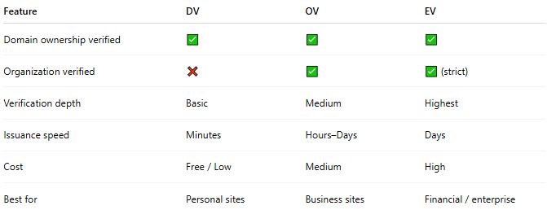
Feature | DV | OV | EV
Domain ownership verified | ✅ | ✅ | ✅
Organization verified | ❌ | ✅ | ✅ (strict)
Verification depth | Basic | Medium | Highest
Issuance speed | Minutes | Hours–Days | Days
Cost | Free / Low | Medium | High
Best for | Personal sites | Business sites | Financial / enterprise

🔒 Important Security Note
# Source: AI Source: Provided by: [Data Path: Persons Table -> ID Column: 1, Name_En Column: Motasem Essam] -> From: [ChatGPT] on [1/18/2026]
🔐 All SSL certificates (DV, OV, EV) use the same encryption strength.
EV improves identity trust, not cryptographic security.

One-sentence summary
# Source: AI Source: Provided by: [Data Path: Persons Table -> ID Column: 1, Name_En Column: Motasem Essam] -> From: [ChatGPT] on [1/18/2026]
EV certificates provide the strongest verification of an organization’s identity and are best for websites where user trust is critical.

